Hindgut and Large Intestine Development

Dual origin of the colon
Segment | Origin | Arterial Supply
Cecum, ascending colon, proximal 2/3 transverse colon | Midgut | SMA
Distal 1/3 transverse colon, descending, sigmoid, rectum, proximal anal canal | Hindgut | IMA
Distal anal canal | Ectoderm of anal pit (proctodeum) | Internal iliac artery (pudendal branches)

The Cloaca & Its Division
The cloaca is an endodermal sac receiving the hindgut dorsally and the allantoic stalk ventrally
Separated from the outside by the cloacal membrane — a bilaminar membrane (no mesoderm) on the embryo's ventral surface between the tail and body stalk
Urorectal septum — formed by fusion of Tourneux fold (craniocaudal) and Rathke's folds (lateral) — divides the cloaca into:
- Ventral: urogenital sinus → bladder, urethra, lower vagina
- Dorsal: rectum + upper anal canal
Urorectal septum fuses with the cloacal membrane → forms the perineal body
Cloacal membrane now divided into:
- Larger ventral urogenital membrane
- Smaller dorsal anal membrane
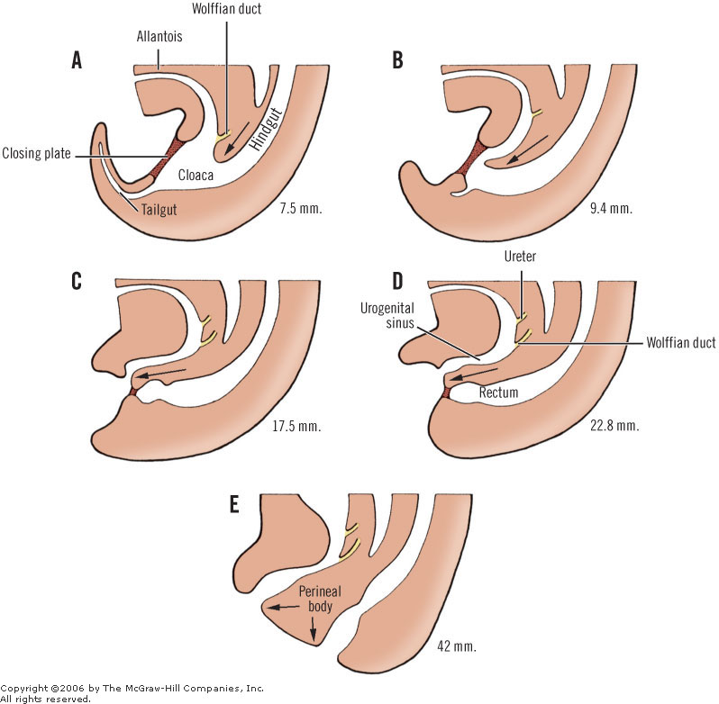
Anal membrane ruptures — leaves no trace
The pectinate line is traditionally considered to correspond to the level of the ruptured anal membrane — though direct evidence is limited
[CLINICAL]Key point: The external anal sphincter forms at the correct anatomical location even if the rectum ends blindly or opens at an ectopic site — explaining why in anorectal malformations, a sphincter is always present and can be used for reconstruction, regardless of where the bowel ends.
[WARNING] The rectum has the highest follicular density — clinically relevant for lymphoid hyperplasia mimicking polyps or IBD on endoscopy

ENS migration — always craniocaudal:
- Ganglion cells reach the colon by the 7th week and complete innervation by the 12th week
- ENS migration is strictly craniocaudal — this is why Hirschsprung disease always involves the rectum and extends proximally, never affecting only a proximal segment while sparing the rectum
- RET/GDNF — primary axis; RET on neural crest cells, GDNF from gut mesenchyme
- EDNRB/EDN3 — especially important for the terminal colon and rectum; explains why EDNRB mutations give longer-segment Hirschsprung
- SOX10, PHOX2B — transcription factors in migrating neural crest cells required for ENS identity
- L1CAM — cell adhesion molecule required for ENS migration; mutations → X-linked Hirschsprung

Colonic villi — a unique fetal structure:
- Villi appear in the 3rd month, peak at the 4th month, then regress by the 7th–8th month
- The mature colon has no villi — their disappearance reflects the shift from absorptive to storage/reservoir function
- Their presence during fetal life maximises surface area for amniotic fluid absorption

Clinical Correlations

Hirschsprung Disease
- Ganglion cells normally reach the colon at 7 weeks and complete migration by 12 weeks
- A developmental arrest at any point → aganglionic segment from that level to the internal sphincter
- Short segment (rectosigmoid) ~80%; long segment (beyond sigmoid) ~15%; total colonic aganglionosis ~5%
- Total colonic aganglionosis presents with small bowel dilatation, not just rectal — challenging diagnosis
- Associated syndromes: Down syndrome (~10% of Hirschsprung), MEN2A (RET mutation shared)
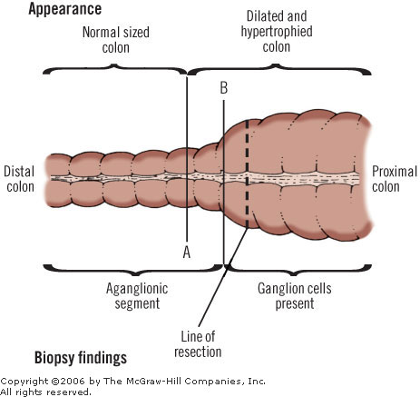
Imperforate Anus
- Anal membrane fails to rupture by 8th week
- Low type: anal membrane persists; bowel present at normal position; simple incision curative
- High type: rectum ends above levator ani; requires posterior sagittal anorectoplasty (PSARP — Peña procedure)
- Associated with genitourinary anomalies in ~50% — always perform spinal and renal USS

Pectinate Line - Clinical Significance (Embryological Basis)
Feature | Above Pectinate Line (Endodermal) | Below Pectinate Line (Ectodermal)
Origin | Hindgut endoderm | Anal pit ectoderm
Arterial supply | Superior rectal (IMA) | Inferior rectal (internal iliac)
Venous drainage | Portal system | Systemic (IVC)
Lymphatic drainage | Internal iliac nodes | Superficial inguinal nodes
Innervation | Autonomic (visceral — painless) | Somatic (painful)
Haemorrhoids | Internal — painless | External — painful
Carcinoma type | Adenocarcinoma | Squamous cell carcinoma

